Dear Parents,
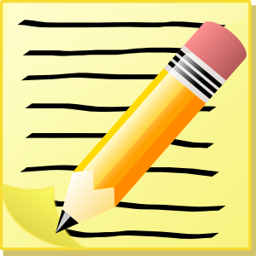
We are very excited to share some new activities and projects for your first grader. At this point in the year, many children are looking for different ways to show their learning and thinking. We recognize that every child has a different learning style and could benefit from different kinds of experiences in and out of the classroom. This is a voluntary activity for any child that would like to participate in an independent project learning experience.
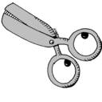
There are a variety of activities to choose from and your child may select to work on one or more of any of the items on the list. This should be an activity that allows your child to flourish in an area of interest while showing creativity and independence. When your child completes one or more of the activities, please bring the project/s into school to share with the class. Have fun!

Enjoy,
The First Grade Teachers

First Grade Projects

- Create your own cereal! Give it a name, a character, ingredients, a game, an advertisement, a prize inside, etc.! Be sure to include the history of the cereal, how you came up with the idea! Remember to be creative!
- Design your own math board game! Include directions, the pieces you need, the game board, and a creative title!
- Create your own Alphabet Book. Your Alphabet Book should tell a story. Before you create your book, be sure to read many different types of Alphabet Books from school or the library to get some ideas of how an Alphabet Book looks! Your book should include pictures or drawings of a particular topic. For example, animals, foods, hobbies, names, etc.
- Create your own non-fiction book about a topic you know a lot about! Be sure your information is based on real facts. Use real photos for your book. You should research your topic to find facts that you did not already know!
- Create your own story character. Make a puppet that represents the character. Write a description of how you came up with the idea for your character. Write a story or a play about your character. Be creative. Make sure you include lots of details!

- State report: Select a state. Cut a piece of poster board in the shape of the state and decorate it with words/pictures telling about the state bird, state flower, state capital, year it became a state, and one fun place to visit in the state.

- Create a poster for an animal that is in danger of becoming extinct. Make sure you represent the habitat where the animal lives. What can you do to help? Make sure you list what you want people to know about your animal and why it is so important that your animal survives.

